SOUMITH SRIPATHI
8 OCTOBER 2025
2403A51340

ASSIGNMENT 11.2

TASK 1 : Stack Implementation
generate a Stack class with push, pop, peek, and is_empty methods.
Sample Input Code:
class Stack:
pass

PROMPT : Implement a basic Stack data structure using a Python class. Your class should include the following methods:
__init__ for initialization
push(item) to add an item to the top
pop() to remove and return the item from the top (raising an exception if the stack is empty)
peek() to return the item from the top without removing it (also raising an exception if empty)
is_empty() to check if the stack contains any items.
PROGRAM :

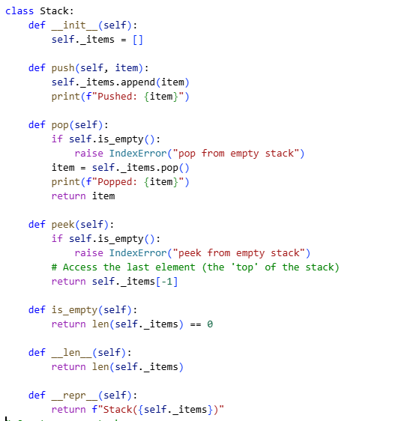
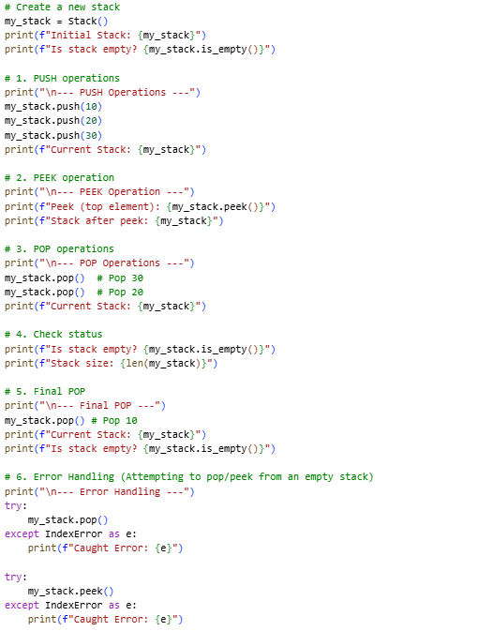

OUTPUT :
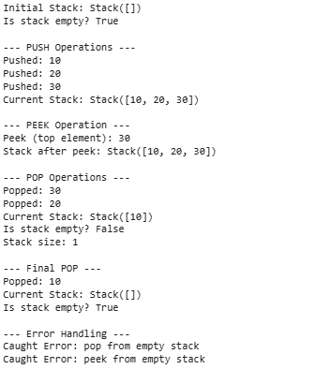
EXPLANATION :
Initial State & Push:
The stack starts empty (Stack([])).
Items 10, 20, 30 are pushed. 30 is the last item added, so it's at the top. The internal list is now [10, 20, 30].
Peek:
Peek (top element): 30 confirms that the last item pushed is correctly identified as the top without being removed.
Pop (LIFO in Action):
The first two pop() calls remove 30 then 20. This demonstrates LIFO: the last item pushed (30) is the first item popped.
Final Pop & Empty Check:
The last item, 10, is popped, leaving the stack empty (Stack([])).

TASK 2 : Queue Implementation

implement a Queue using Python lists.
Sample Input Code:
class Queue:
pass

PROMPT :
Implement a basic Queue data structure using a Python class and a standard list.
Your class must include the following methods:
__init__ for initialization
enqueue(item) to add an item to the rear
dequeue() to remove and return the item from the front (raising an exception if empty)
is_empty() to check if the queue is empty

PROGRAM :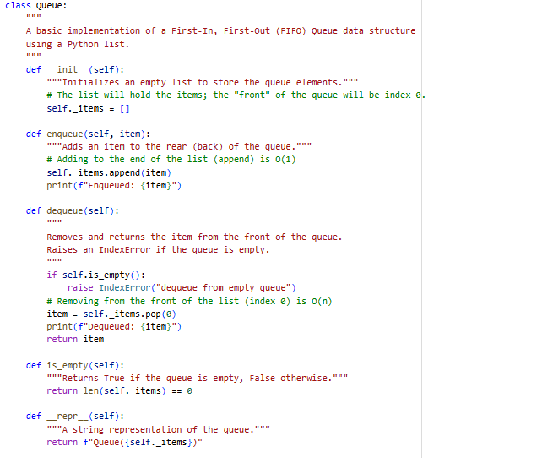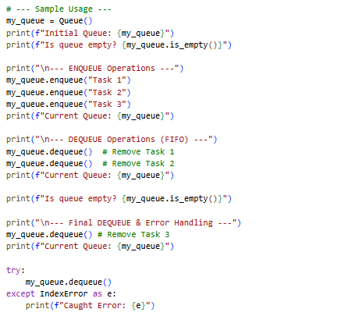
OUTPUT :
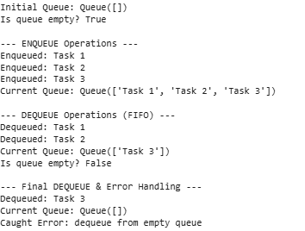
EXPLANATION :
Storage (self._items):
A Python list is used. We designate index 0 of the list as the front of the queue.enqueue(item) (Adding):
Items are added to the rear using list.append().
Adding to the end of a Python list is a very efficient O(1) (constant time) operation.
dequeue() (Removing):
Items must be removed from the front to maintain the FIFO order. This is done using list.pop(0).
Efficiency Note: Removing an element from the start of a Python list is an O(n) operation
is_empty(): Checks if the list has a length of zero before performing a dequeue.

TASK 3 : Linked List
generate a Singly Linked List with insert and display methods.
Sample Input Code:
class Node:
pass

PROMPT :
__init__ method to initialize the head, an
insert(data) method to add a new node to the beginning of the list, and a
display() method to print all elements sequentially."

PROGRAM :
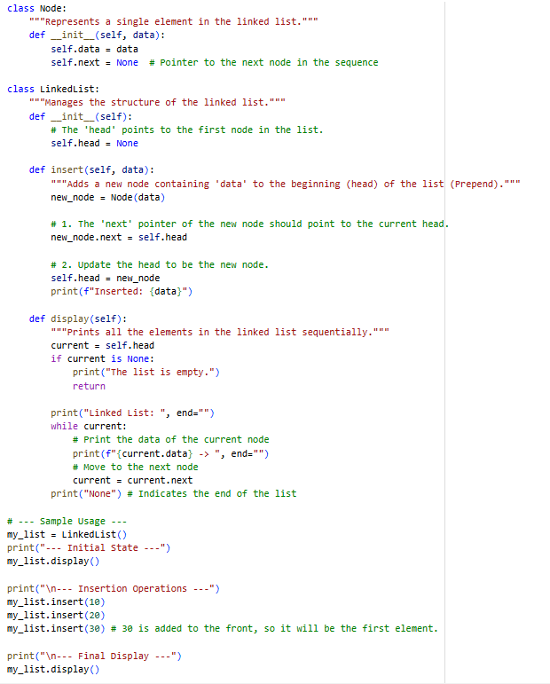

OUTPUT :
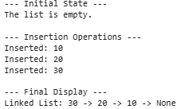

EXPLANATION :
Node Class:
This is the basic building block.
It holds the data (the value stored in the element).
It holds the next pointer (a reference to the next Node object in the sequence). If it's the last node, next is None.
LinkedList Class:
This class manages the entire list, primarily through the head pointer, which always points to the first Node of the list.
insert(data) Method (Prepend):
The sample code implements prepending, which is adding a new node to the beginning of the list. This is efficient, running in O(1) (constant time).
Steps:
A new Node is created.
The new_node.next pointer is set to point to the current self.head. (The new node now points to the old list).
TASK 4 : Binary Search Tree (BST)
create a BST with insert and in-order traversal methods.
Sample Input Code:
class BST:
pass

PROMPT :
insert(key) method to add a new node while maintaining the BST property
inorder_traversal() method that prints the nodes in non-decreasing order.

PROGRAM :
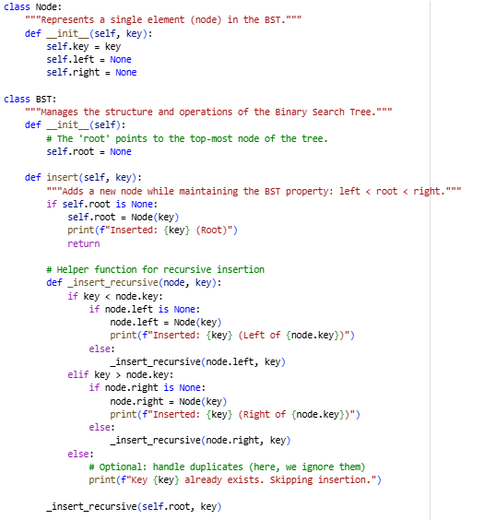
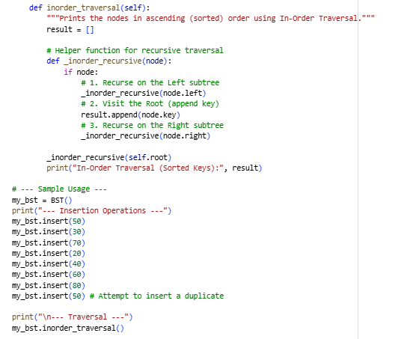
OUTPUT :
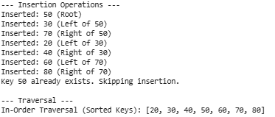
EXPLANATION :
All keys in the left subtree are less than the node's key.
All keys in the right subtree are greater than the node's key.
Node Class: The basic building block. It stores the key (data) and two pointers: left and right, which reference its child nodes or are None.
BST Class: Manages the entire tree structure through the root pointer.
insert(key) Method:
The method is recursive, starting at the root.
It compares the new key with the current node's key.
If key is less than the current node's key, it proceeds to the left child.
If key is greater than the current node's key, it proceeds to the right child.
The process repeats until an empty spot (None) is found, where the new Node is placed. This preserves the BST property.
inorder_traversal() Method:
This is a specific type of Depth-First Search (DFS) traversal.
It follows a sequence: Left → Root → Right.
TASK 5 : Hash Table
implement a hash table with basic insert, search, and delete methods.
Sample Input Code:
class HashTable:
pass

PROMPT :
__init__ to initialize the list of buckets
an insert(key, value) method to add a new key-value pair
a search(key) method to retrieve the value associated with a key (or return None)
delete(key) method to remove a key-value pair.
PROGRAM :
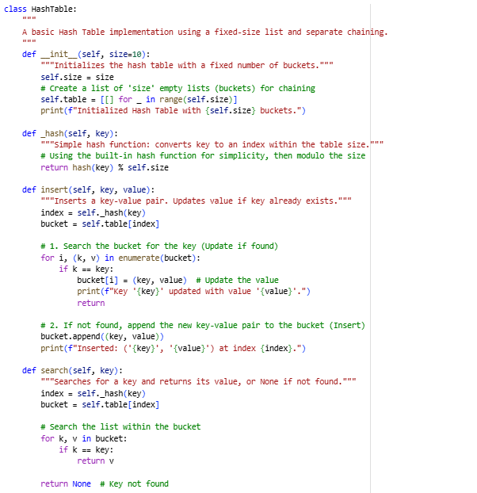
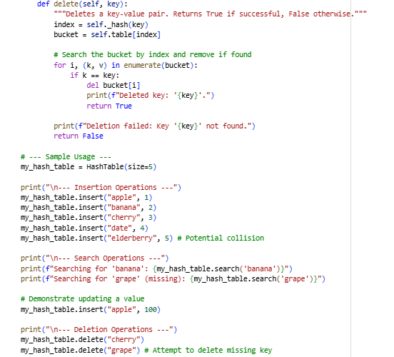
OUTPUT :
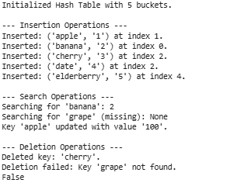
EXPLANATION :
Storage (self.table): The core is a fixed-size list of lists, where each inner list is a bucket.
Hashing Function (_hash):
This function takes a key (e.g., a string) and transforms it into an index (a valid number between 0 and size - 1).
The implementation uses Python's built-in hash() function for the key, and then applies the modulo operator (% self.size) to ensure the resulting index fits within the size of the table.

TASK 6: Graph Representation
implement a graph using an adjacency list.
Sample Input Code:
class Graph:
pass

PROMPT :
__init__ to initialize the list of buckets
insert(key, value) method to add a new key-value pair
a search(key) method to retrieve the value associated with a key (or return None)
delete(key)
PROGRAM :
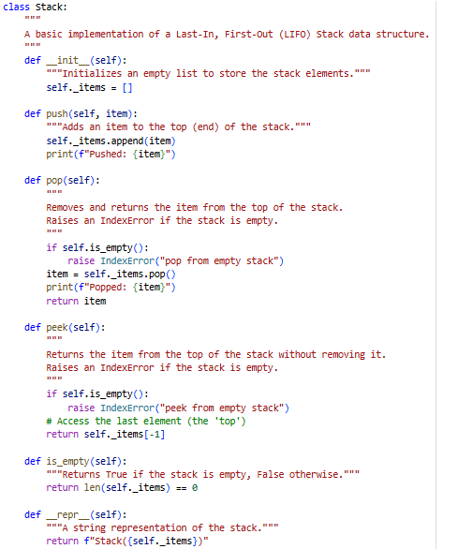
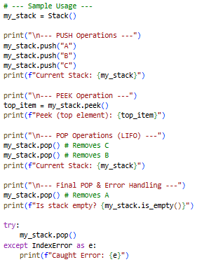
OUTPUT :
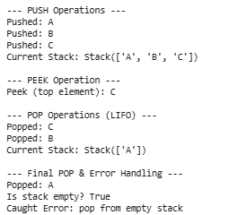
EXPLANATION :
self._items). The list's end is designated as the stack's top.
push(item): Uses list.append(item). Adding to the end of a list is very fast (O(1)).
pop(): Uses list.pop(). Removing from the end of a list is also very fast (O(1)) and ensures LIFO order. It includes error checking for an empty stack.
peek(): Uses negative indexing (self._items[-1]) to look at the last element without removing it.
Efficiency: All core operations (push, pop, peek, is_empty) are implemented efficiently with O(1) (constant time) complexity.

TASK 7: Priority Queue
implement a priority queue using Python’s heapq module.
Sample Input Code:
class PriorityQueue:
pass

PROMPT :
__init__ for initialization
insert(item) to add an item to the queue
extract_min() to remove and return the item with the highest priority (lowest value)
is_empty() to check if the queue is empty
PROGRAM :
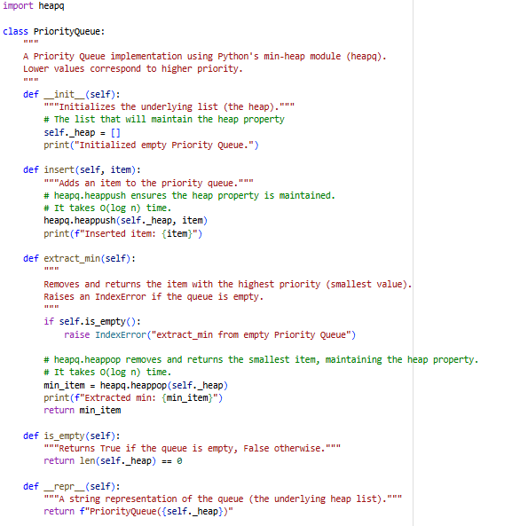
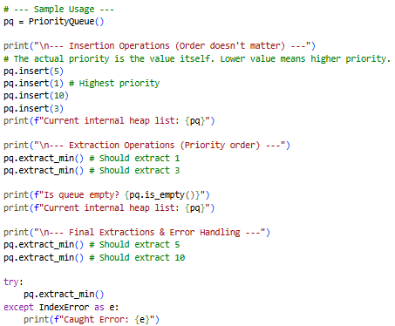
OUTPUT :
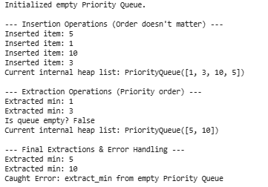
EXPLANATION :
Storage (self._heap): The priority queue is backed by a standard Python list (self._heap), but its elements are kept in heap order by the heapq functions.

